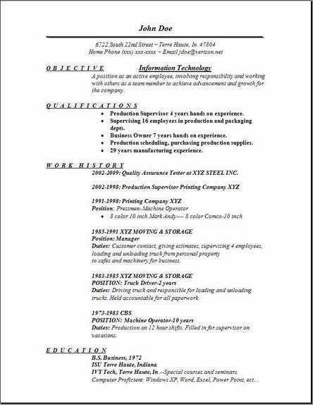
John Doe
6722 South 22nd Street-Terre Haute, In 47804 Home Phone (xxxxxx-xxxx-Emall jdoe@verizon.net
OBJECTIVE
Information Technology
A position as an active employee, involving responsibility and working with others as a team member to achieve advancement and growth for the company
QUALIFICATIONS
• Production Supervisor 4 years hands on experience. • Supervising 16 employees in production and packaging depts.
⚫ Business Owner 7 years hands on experience.
• Production scheduling, purchasing production supplies. ⚫ 29 years manufacturing experience.
WORK HISTORY
2002-2009: Quality Assurance Tester at XYZ STEEL INC. 2002-1998: Production Supervisor Printing Company XYZ
1991-1998: Printing Company XYZ Position: Pressman-Machine Operator
• 8 color 10 inch Mark Andy-8 color Comco-10 inch
1985-1991 XYZ MOVING & STORAGE
Position: Manager
Duties: Customer contact, giving estimates, supervising 4 employees,
loading and unloading truck from personal property
to safes and machery for business.
1983-1985 XYZ MOVING & STORAGE
POSITION: Truck Driver-2 years
Duties: Driving truck and responsible for loading and unloading trucks. Held accountable for all paperwork
1973-1983 CBS
POSITION: Machine Operator-10 years
Duties: Production on 12 hour shifts. Filled in for supervisor on
vacations
EDUCATION
B.S. Business, 1972
ISU Terre Haute, Indiana
IVY Tech, Terre Haute, In-Special courses and seminars.
Computer Proficient: Windows XP, Word, Excel, Power Point, ect...

